Operator Button Mapping (Mar 13, 2017)

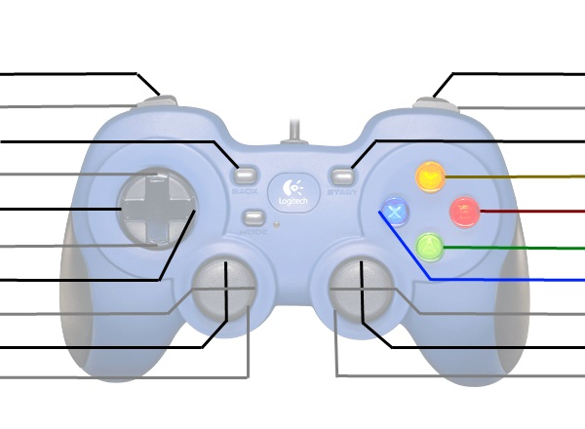

Boiler Shot

Shooter Speed -

Reverse Shooter

Kill Everything

Key Shot

Shooter Speed +

Winch Lower

Winch Lift

Hopper Expand

Intake

Gear Flap

Driver Button Mapping (Mar 13, 2017)



Drive Forwards

Left Fwd/Back

Kill Everything

Shift Gears

Right Fwd/Back